Error Bars AoP calculations

12th June 2017

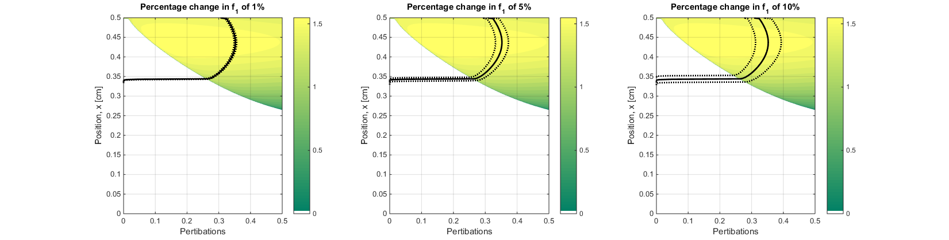 $f_{1}=f_{1} ± Percentage Change×f_{1}$

Found problem with path finder !!!!! Check 3rd work book!